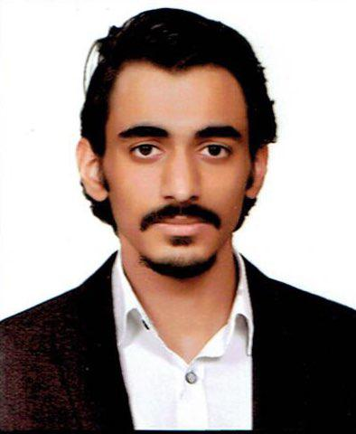**Ahmed Ali Abdulrazzaq**

Email: [agonimous6@gmail.com](mailto:agonimous6@gmail.com)

Phone: 07811304928

Address: Al Saydia, Khyzaran St.

Date of Birth: 11/May/2001

* **Characteristics**

-Fluent in Arabic and English Languages.

-Great communicational skills and charisma.

-Proficient in writing and speaking English.

-The ability to pay attention to details.

-Self-taught musician and writer.

* **Experience**

-Hosting dialogue sessions and have a decent experience in presentations.

-Using Microsoft Office (Word, Power Point, and Excel).  
-Editing and designing with Photoshop.

-Familiar with all social media platforms.

-Have a 2 year experience with composing music and writing poetry.

* **Awards & certificates**

-A certificate of participation in *IYLEP* (Iraqi Young Leaders Exchange Program).

* **Education** (Highschool 12th grade student. Studying Maths and Science).